ASSIGNMENT

1. Write a python program to find the number of times 4 appears in the tuple.

Tuplex= {2,4,5,6,2,3,4,4,7}

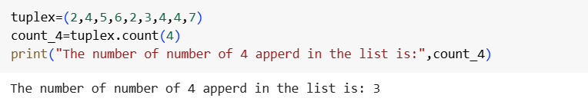

Output

The number of 4 appeared in the list is : 3

1. Write a python program to convert a list to a tuple.

List= [5,10,7,4,15,3]

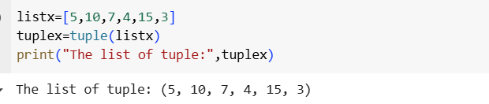

Output

The list of tuple: (5,10,7,4,15,3)

1. Write a python program to calculate the sum of the numbers in a given tuple.

Tuple= [(1,2), (3,4), (5,6)]

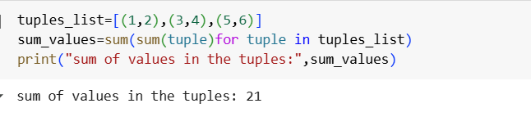

Output

Sum of values in the tuples:21